# Introduction to the Labour Force Survey (LFS) and Annual Population Survey Workshop: Using LFS documentation

The LFS has extensive documentation to help you understand and use the data. This exercise is designed to show you how to navigate and use the LFS documentation**.**

## Task: Identify relevant variables to research zero-hour contracts

Scenario: You are interested in zero-hour contracts (casual contracts in which the employer does not guarantee the individual any hours of work each week). You want to carry out some exploratory analysis to find out who is reliant on zero-hour contracts. You are interested in exploring if migrants are more likely to have zero-hour contracts and if there are geographical differences.

### 1. UKDS Catalogue page

This activity will start by looking at data available from the October-December 2020 Quarterly Labour Force Survey (SN 8777).

[Start by navigating to the catalogue page for the dataset](https://beta.ukdataservice.ac.uk/datacatalogue/studies/study?id=8777).

### 2. LFS User Guide Vol 2. – Questionnaire

On the catalogue page, navigate to the documentation tab.

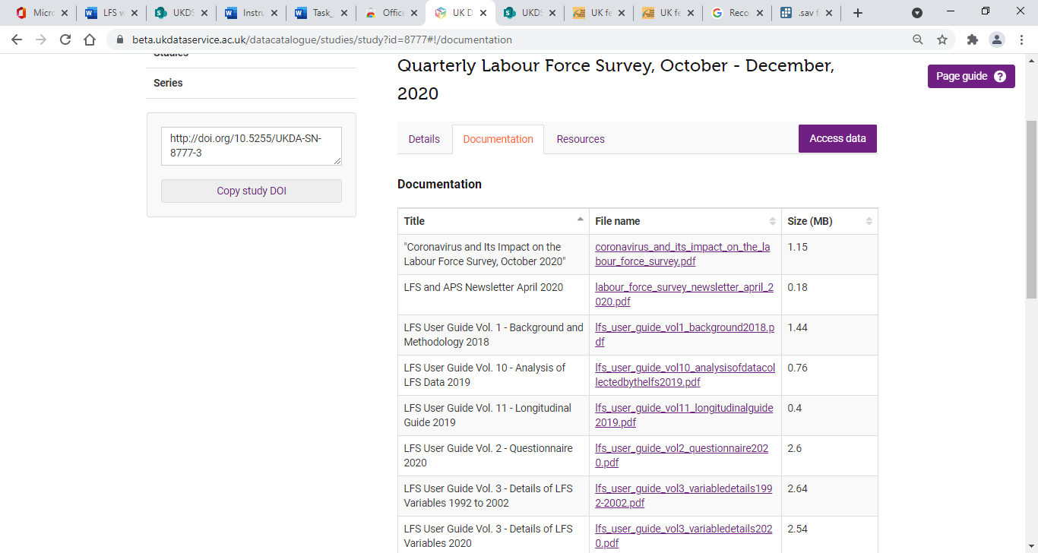

Find and open ‘LFS User Guide Vol 2. – Questionnaire’. Locate any questions that collect information about zero-hour contracts. Hint: use the find function (CTRL+F) to search for ‘zero’.

Question 1: What is the name of the variable assigned to the question that asks about zero-hour contracts?

Note that the question is a **multi-response variable** – up to three responses can be provided. It will be important to know how multiple-response variables are handled in the dataset.

### 3. LFS User Guide Vol. 3 – Details of LFS Variables 2020

Find out more information about variables capturing zero-hour contracts by looking at ‘LFS User Guide Vol. 3 – Details of LFS Variables 2020’. Again, start by searching the document for ‘zero’.

You should discover that there are more variables in Vol. 3 that include information about zero-hour contracts. This is because Vol. 3 includes information about the derived variables.

Look at the details for FLEX10 on p.163. Here we can find out additional information including:

* The question is asked in all quarters and waves, but this is a recent change (since 2020)
* You can find out details about multiple response variables at the beginning of the user guide (see page 3).

**Question 2:** What does the (1-3) in the name FLEX10(1-3) refer to?

Question 3: What is the name of the derived variable that is labelled: Whether respondent works zero hours contract?

### 4. LFS User Guide Vol. 4 – Standard Derived Variables 2016

How has FLEXW7 been derived?  You can learn more about derived variables by examining ‘Vol. 4 – Standard Derived Variables 2016’. Search for FLEXW7 and you will find the details on p.140.

**Question 4:** How does FLEXW7 vary from FLED10?

## Additional: Explore options for analysis

### Zero-hour contracts among migrants to the UK

Find out if you can explore zero-hour contracts among migrants to the UK. Consider if there are variables to identify immigrants to the UK? Can you identify by country of birth or origin? (Potential search terms: ‘birth’ or ‘country’.) What is included in the dataset?

### Geographical differences in zero-hour contracts

Is it possible to examine geographical differences in relation to zero-hours contracts? What variables can you find relating to geography? Which versions of the data are they included in?

### Movement in and out of zero-hours contract

Can you carry out analysis to see if individuals move in and out of zero-hour contracts over time? What steps would you take to find out?

## Answers

Question 1: What is the name of the variable assigned to the question that asks about zero-hour contracts?

Answer: The variable **name is FLEX10**. The question is: *‘Some people have special working hours arrangements that vary daily or weekly. In your (main) job is your agreed working arrangement any of the following...’*

**Question 2:** What does the (1-3) in the name FLEX10(1-3) refer to?

Answer: The (1-3) relates to the note that **‘Respondents may give up to three responses’**. The first, second, and third responses are contained in different variables which have the suffixes 1, 2, or 3 added; for example, first responses are recorded in a variable called FLEX101. To find all the respondents who mention zero-hour contracts, you would need to sum responses across FLEX101, FLEX102 and FLEX103.

Question 3: What is the name of the derived variable that is labelled: Whether respondent works zero hours contract?

Answer: The variable **name is FLEXW7.**

**Question 4:** How does FLEXW7 vary from FLED10?

Answer: **FLEXW7** is derived from FLEX10(1-3), the variable only provides information about zero-hour contracts, it is a dichotomous variable (yes, no). It includes all mentions of whether a person has a zero-hour contract. **FLED10** is derived from FLEX10(1-3) responses, it has 10 categories of which zero-hour contracts is just one. FLED10, records the 'main' type of agreed work arrangement from the responses collected in FLEX10(1-3). Therefore, FLED10 = 7 applied when the main type of agreed work arrangement is a zero-hours contract. Selecting FLED10 = 7 will give a smaller number than FLEXW7 = 1.

**Zero-hour contracts among migrants to the UK**

We can find the following, variables relating to migration:

* CAMEYR – In which year did you first arrive in the UK?
* CRY12 - In which country were you born?
* CRYO7- Country of birth
* CRYOX7 - CRYOX7- Country of birth (other)

If we check the data dictionary, we can find the EUL version contains grouped versions of CRYO7 and CRYOX7

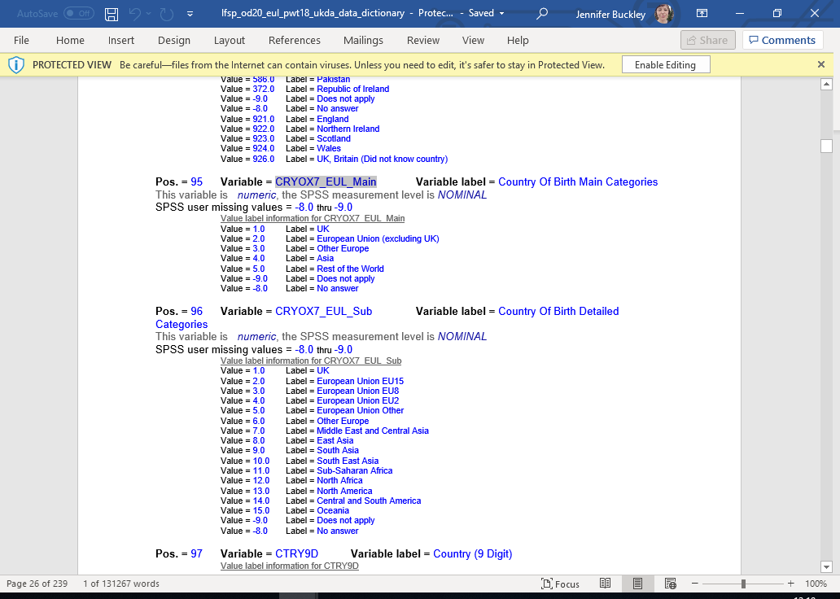

**What variables can you find to control for geography in the analysis?**

Answer: Variables relating to geography:

* GOR9D – Region
* LAUA - Local authority district

In Vol. 3, notes for LAUA indicate it is an APS variable. If you check the data dictionary for the EUL version, you can see it is not included. To see, if the research is possible with the APS, you would then need to see if information about zero-hours contracts is held in the APS.

**How would you carry out analysis to see if individuals move in and out of zero-hour contracts over time?**

Volume 3 tells us that FLEXW7 is in Spring and Autumn quarters only. To look at movement in and out of zero-hours contracts, we would need to look across 5 quarters. If we looked at the data dictionary for [Labour Force Survey Five-Quarter Longitudinal Dataset, October 2019 - December 2020](https://beta.ukdataservice.ac.uk/datacatalogue/studies/study?id=8780#!/documentation), we would see that FLEXW7 is included.